- Problem: Cross Correlation Analysis of variable input signals:
x1=[1,2,4,7,12]
x2=[0,1,1,2,6,9,14]

Logical Solution:
- r_{xy}(n)=$\sum_{k=-∞}^{∞}{x\left(k\right)*y(k-n)}$

Source Code:
def correlation(x,x0,y,y0):
t=[]
rxy=[]
mxx=-100000
# rxy(n)= sum(k=-inf to inf) x(k)*y(k-n)
mx=max(len(x),len(y))
for n in range(-mx,mx+1):
rxy.append(0)
t.append(n)
for k in range(-mx,mx+1):
try: # if positive index exist?
if k>=(-x0): a=x[k+x0] # if negative index exists?
else: a=0
except: a=0

try:
if (k-n)>=(-y0): b=y[k+y0-n]
else: b=0
except: b=0

rxy[-1]+=a*b

if mxx<=rxy[-1]:
delay=t[-1]
mxx=rxy[-1]

return t,rxy,(delay,mxx)

x1=[1,2,4,7,12]
x2=[0,1,1,2,6,9,14]
t,rxy,result=correlation(x1,0,x2,0)
print("Time Sequence:",t)
print("Correlation Values:",rxy)
print("Delay:",result[0])
print("Maximum Value:",result[1])

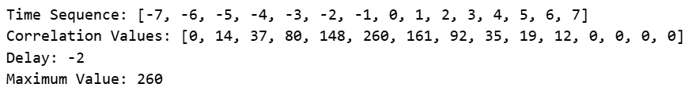

plt.stem(t,rxy)
plt.grid(True)
plt.show()

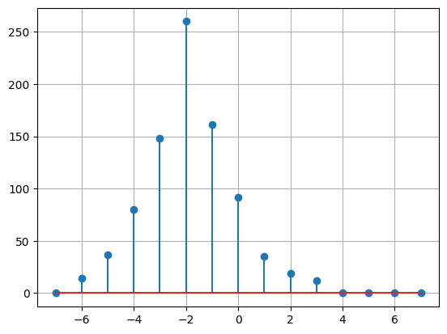
Figure-Correlated Signal

Discussion:
- In signal processing, when two signals are correlated, it means they have mathematical similarity to each other.
- It represents how much two signals similar each other as one slide past the other in time.

- Problem: Cross Correlation of Sine and Shifted Sine Signal

Logical Solution:
- r_{xy}(n)=$\sum_{k=-∞}^{∞}{x\left(k\right)*y(k-n)}$

Source Code:
import numpy as np
import matplotlib.pyplot as plt

f=1
t=np.linspace(-1,1,100)
sinx=np.sin(2*np.pi*f*t)

shifted_sign=list(sinx)
t=5
for i in range(t):
shifted_sign.insert(0,0)

shifted_sign=np.array(shifted_sign)

cross_corr=np.correlate(sinx,shifted_sign,'full')

plt.figure(figsize=(12,8))

plt.subplot(3,1,1)
plt.stem(sinx)
plt.grid(True)

plt.subplot(3,1,2)
plt.stem(shifted_sign)
plt.grid(True)

plt.subplot(3,1,3)
plt.stem(cross_corr)
plt.grid(True)

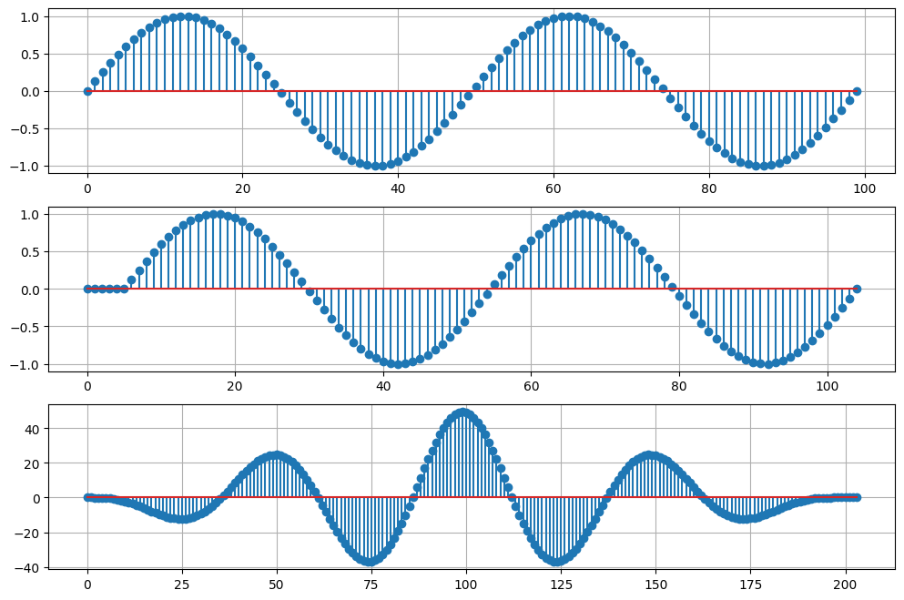
Output-Cross Correlation of Sine & Shifted Sine Signal

Discussion:
- The cross-correlation of a sine wave and a shifted sine wave represent how much the second signal is delayed (or shifted) relative to the first one.
- Cross-correlating two sine waves, the result is not a flat line or a single spike. The result is another sinusoidal wave specifically, a cosine wave.

- Problem: Auto Correlation of Cosine Signal

Logical Solution:
- r_{xx}(n)=$\sum_{k=-∞}^{∞}{x\left(k\right)*x(k-n)}$

Source Code:
import numpy as np
import matplotlib.pyplot as plt
f=1
t=np.linspace(-1,1,100)
cosx=np.cos(2*np.pi*f*t)
corr=np.correlate(cosx,cosx,'full')

plt.figure(figsize=(12,6))
plt.subplot(2,1,1)
plt.stem(cosx)
plt.grid(True)
plt.subplot(2,1,2)
plt.stem(corr)
plt.grid(True)
plt.show()

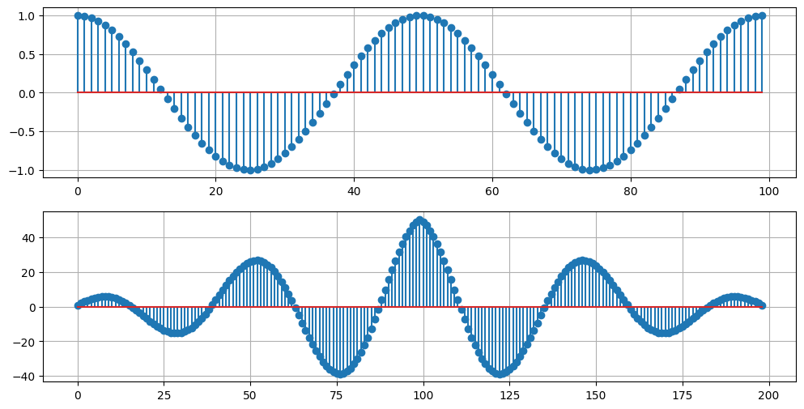
Output- Auto Correlation of Cosine Signal

Discussion:
- A cosine signal and its autocorrelation result represents that it is a Power Signal as power is finite.
- The autocorrelation function confirms this classification based on the value at Zero Lag.
- The autocorrelation of a cosine signal measures how much the cosine wave resembles itself at different time delay.
- This tells that the self-similarity of the wave oscillates just like the wave itself does.

